Virtual Clothes Try-on

Jorge Olivares

Robin Martinez

Alan Vela

**Interface Control Document**

REVISION – 0.2

19 February 2022

Interface Control Document

for

Virtual Clothes Try-on

Prepared by:

_____________________________

Author Date

Approved by:

_____________________________

Jorge Olivares Date

_____________________________

Prof. Kalafatis Date

_____________________________

Skyelar Head Date

**Change Record**

|  |  |  |  |  |
| --- | --- | --- | --- | --- |
| **Rev.** | **Date** | **Originator** | **Approvals** | **Description** |
| **-** | [date here] | [person’s name] |  | Draft Release |

**Table of Contents**

**Table of Contents III**

**List of Tables IV**

**List of Figures V**

**1.** **Executive Summary 1**

**2.** **Introduction 2**

2.1. Background 2

2.2. Overview 2

2.3. Referenced Documents and Standards 2

**3.** **Operating Concept 3**

3.1. Scope 3

3.2. Operational Description and Constraints 3

3.3. System Description 3

3.4. Modes of Operations 3

3.5. Users 3

3.6. Support 3

**4.** **Scenario(s) 4**

4.1. Scenario Name #1 4

**5.** **Analysis 4**

5.1. Summary of Proposed Improvements 4

5.2. Disadvantages and Limitations 4

5.3. Alternatives 4

**List of Tables**

No table of figures entries found.

**List of Figures**

# Figure 1 - System Overview Flowchart

# Overview

This document describes the interfaces between all the different subsystems of Virtual Clothing Try-On. The system is designed to be centered by three different subsystems: the android application, database, and neural network. A system diagram of how the different subsystems interact is shown in **figure ?.**

Figure 1 - System overview flowchart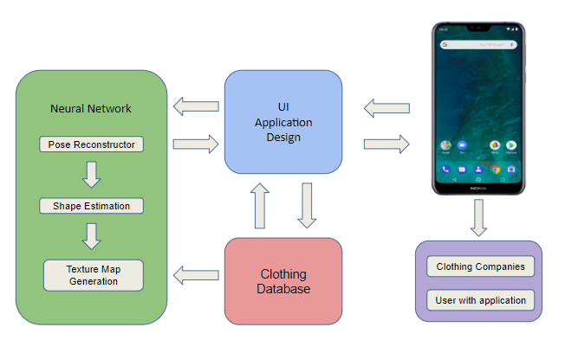

# References and Definitions

## References

|  |  |  |
| --- | --- | --- |
| **Document Name** | **Revision/ Release Date** | **Publisher** |
| People Snapshot  Datasheet | 2018 | Computer Vision Foundation |
| semantic human texture stitching | 2018 | Computer Vision Foundation |

## Definitions

MySQL My Structured Query Language

GUI Graphical User Interface

RGB Red Green Blue

SMPL Skinned Multi-Person Linear Model

3D 3-dimensional

APK Android Package

IP Internet Protocol

# Physical Interface

## Model

An Android Phone that can use OS 7.0 Nougat and that is also compatible with Augmented Reality applications is needed to provide a video able to create the 3D model.

## Camera

The phone has to use a back camera that can capture video in RGB. The camera needs to process videos that are at least 24 frames per second and colored.

# Database Interface

The subsystems will interact with MySQl database through an IP established in the host services. Data requests will be managed with Python to ensure flexibility between the subsystems. Each of the systems will be able to communicate with the database independently.

# Graphic User Interface

The user will interact with the GUI on their android phone that was created on Android Studio using Java. Users will be able to login and have a profile with information they will be able to edit on. There will also be a shopping cart that the user will be able to add or remove items they want to purchase. This allows the user to freely and conveniently use the application.

# Machine Learning Model to App Communication

For communication between the SMPL model and the app interface we will be using Python-for-Android. This would allow us to package the machine learning code into android APKs that can be uploaded to the Android app store. Python-for-android would compile the Python interpreter with its dependencies, backend libraries and python code.